Andrew Dent Student Elective Scholarship - reflective report
Elective in Papua New Guinea 1/7/18 - 15/7/18
Harley Owens

As a recipient of the Andrew Dent Student Elective Scholarship, I was able to arrange a two-week medical elective with a colleague at the Kompiam District Hospital in Enga Province, Papua New Guinea. Located in the highlands northwest of the country, Kompiam is nestled in a mountainous valley that is reached via a two-hour trip from the nearest regional centre along a rocky mountain ‘road’ that only a 4WD could handle.

Within a few hours of arriving at the hospital compound and settling into the student living quarters (a two bedroom house amongst other houses used by all of the hospital staff), our first patient was flown in via Kompiam’s short, grassy airstrip. She had been sent to us as an emergency patient, having sustained a machete chop wound through her face as part of a domestic violence situation between her and one of her husband’s other wives. Moments after her arrival, we were scrubbing into theatre to clean her wound and establish her airway. It was utterly bizarre seeing a patient with what was essentially a coronal section through her face in a relatively stable condition, and even more bizarre being part of the theatre team suturing her face back into place in anticipation of more in-depth facial reconstruction. Following the procedure, the patient was taken to radiology, and we were instructed on how to operate the X-ray machine. After taking images for this first patient, we were given the keys to the radiology room and delegated as the hospital radiologists for our stay. Shortly afterwards, we saw another patient in theatre: a young boy from the ward with a healing skull fracture that needed a wound clean. I was allowed to take charge with administering ketamine, assessing the wound healing, cleaning it up and redressing.

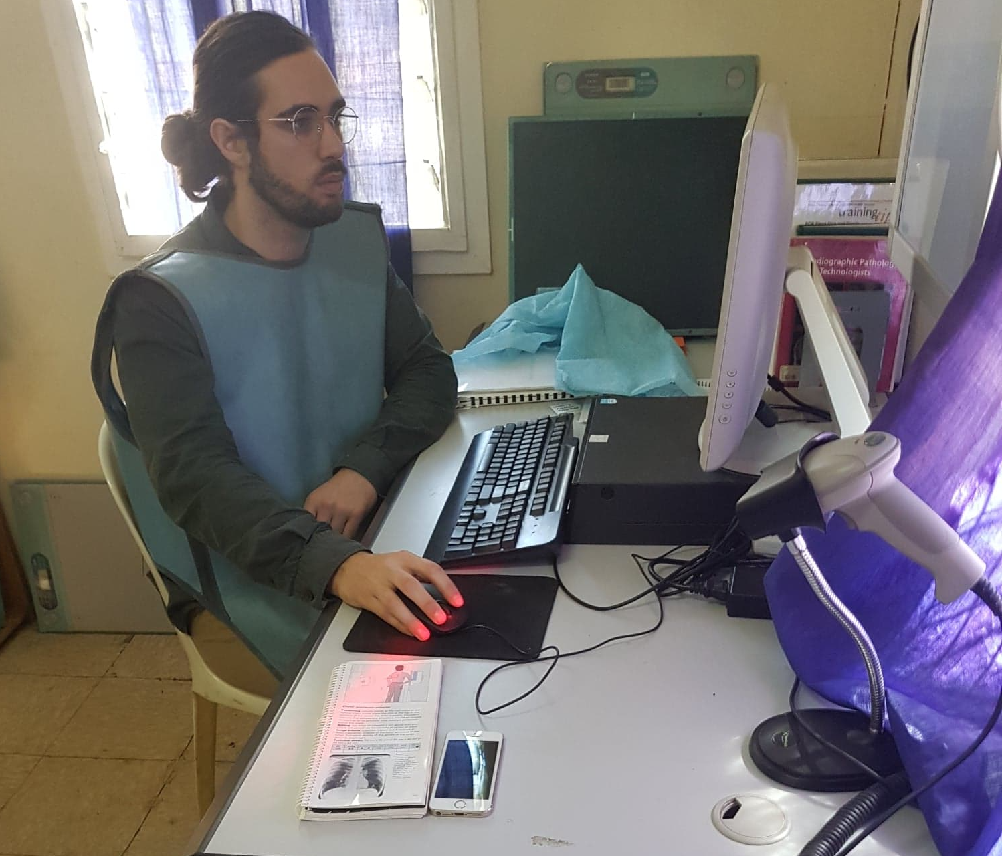

Interpreting X-rays in the radiology suite

We had hit the ground running, and were thrilled with the prospect of this pace being sustained throughout our elective. Unfortunately, we had arrived at the hospital just after a period of conflict between the tribes living in the area surrounding the hospital. This meant that many patients had been either scared away from the hospital or had decided not to present due to personal safety concerns when crossing tribal lines. What followed for us were a few days of very little clinical activity apart from the morning ward rounds, prompting a suggestion from the Director of Nursing Services (DNS) to consolidate their tuberculosis registry in this down time. Although it seemed a dreary task at first, we came to learn a lot about tuberculosis treatment regimes along with the unique difficulties in maintaining said treatment in a remote/rural setting, particularly when documentation standards and patient awareness are lacking.

As we were finishing up our consolidation efforts, the clinical pace picked up again. A pregnant patient had been in labour with her first child for over 24 hours, and concerns about obstructed labour were being considered. The Doctor was away for a week, and the midwives were not comfortable with managing the patient alone, so it was decided that she should be transported to the nearest tertiary hospital two hours away by 4WD. Because of the recent tribal fighting, the hospital drivers (who were part of the tribes involved) were reluctant to drive through tribal lines, leaving the patient without any transport options. My colleague and I had driven 4WDs before, so we put our hands up. From that point on, we became the go-to ambulance officers and we transported a number of patients to and from the hospital, most of which were trauma cases caused by accidental machete chop wounds.

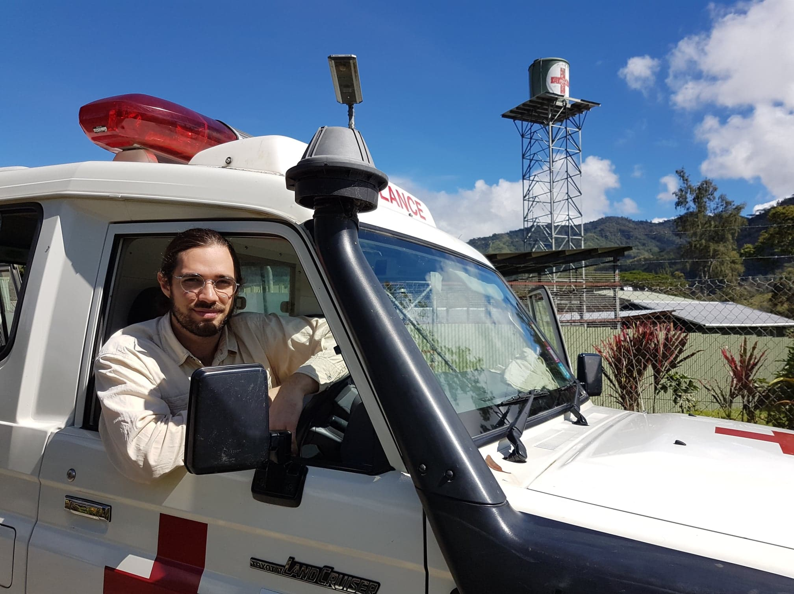

Getting too comfortable in my role as an ambulance officer

Additionally, our role as the ambulance officers allowed the DNS to arrange a mobile health clinic for the villages that could not access the hospital due to the tribal fighting. Packing the ambulance full of nurses, medications, vaccinations and other equipment, we drove up a severely dilapidated, washed-out ‘road’ to a village perched up on one of the mountains looking down into Kompiam. Upon setting up a gazebo in a field in the middle of the village, people started to flood in and we were soon swamped with patients. We were consulting patients much like a GP would, and the range of presentations that we came across really put our knowledge to the test. We took histories (with the help of an interpreter), performed examinations, made diagnoses and prepared management plans with basic prescriptions. In some cases, the presentation was urgent enough that the patients were strongly encouraged to admit themselves to the hospital. Unfortunately, despite the potential seriousness of their condition, they always chose not to travel to the hospital because of the tribal conflict. We made arrangements for patient follow-up when the next mobile health clinic came along, but we were left uncertain as to whether they would receive the care that they deserve. This reality was hard for us to stomach, but illustrated to us the impact of tribal relations on day-to-day life for PNG villagers. Apart from this, we managed to vaccinate hundreds of children, thereby helping to rise the severely low vaccination rate that was the bane of the DNS’ existence, as well as provide sexual health education to the young men and women of the village.

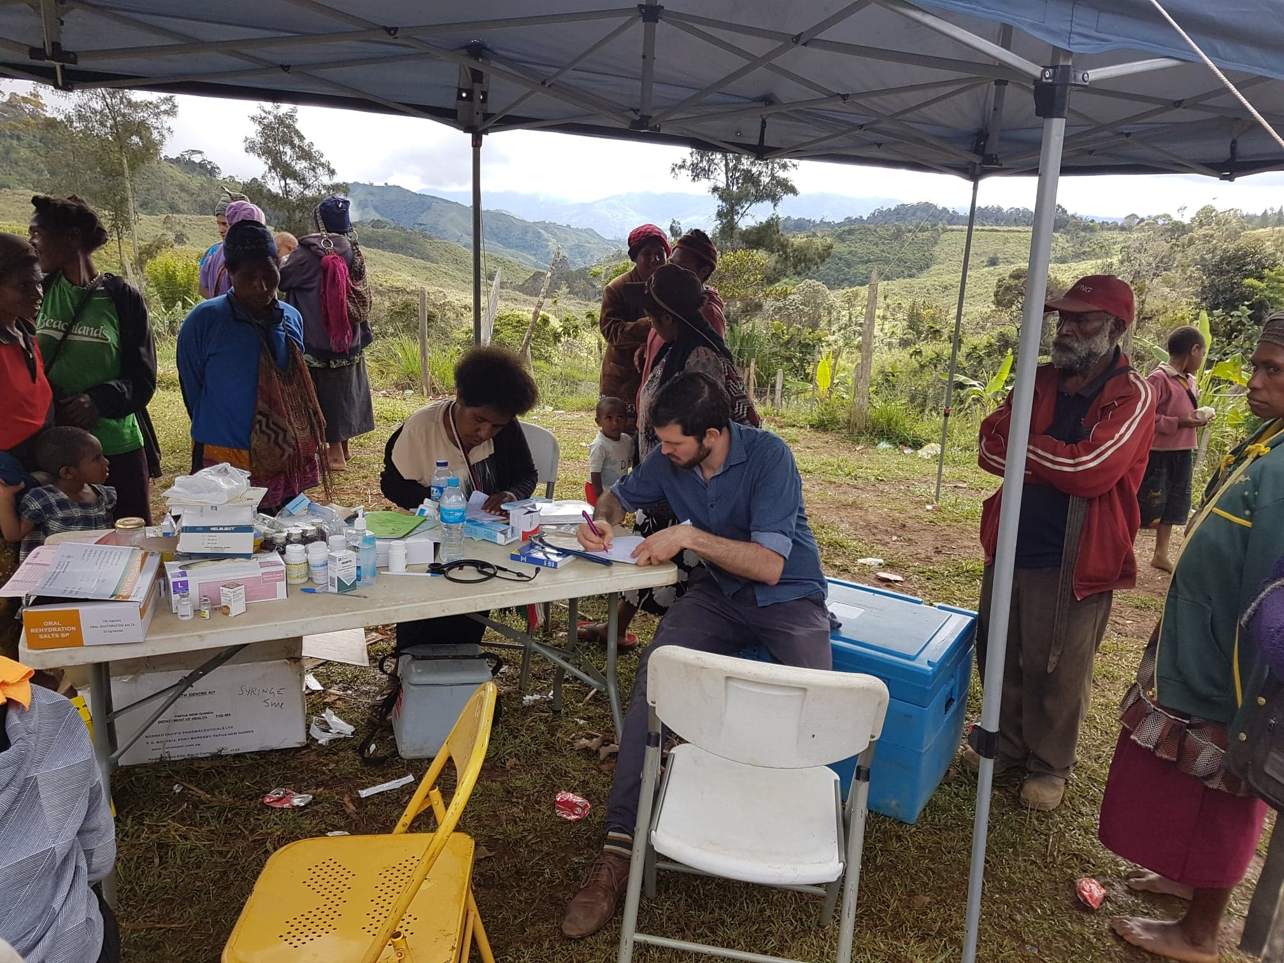

My colleague at work in the mobile health clinic

In all, although the clinical pace in the hospital didn’t live up to our initial expectations, we were still able to learn a lot about how a district hospital is run, how treatment regimes change in this setting, and some of the difficulties involved in managing cultural considerations alongside appropriate medical and surgical care. I also learnt a lot about Papua New Guinea and its beautiful, friendly people, and got to take in some of the breathtaking views that are on offer when driving along the mountain roads. For someone who is interested in pursuing a career as a rural generalist practitioner, I got a lot out of this elective. It helped affirm for me that this is the kind of medicine I want to practice, and I am extremely thankful to the St. Vincent’s Pacific Health Fund for helping me organize this elective.

